***Bahria University,***

***Karachi Campus***

**

***COURSE: SEN 310 WEB ENGINEERING LAB***

***TERM: Fall 2022, CLASS: BSE- 6A***

***SUBMITTED BY:***

***SADIA AMBREEN_____***

*(Name)*

*__****02-131192-0****56*

*(Enrollment No.)*

***65166____***

*(Registration No.)*

***SUBMITTED TO:***

*ENGR.RAHAMEEN/ENGR.TALHA BIN SAEED*

***INDEX***

|  |  |  |  |  |
| --- | --- | --- | --- | --- |
| **S.NO** | **DATE** | **LAB NO** | **LAB**  **OBJECTIVE** | **SIGN** |
|  |  |  |  |  |
|  |  |  |  |  |
|  |  |  |  |  |
|  |  |  |  |  |
|  |  |  |  |  |
|  |  |  |  |  |
|  |  |  |  |  |
|  |  |  |  |  |
|  |  |  |  |  |
|  |  |  |  |  |
|  |  |  |  |  |

***web engineering lab # 1***

***Task # 1: code***

<!DOCTYPE html>

<html lang="en">

<head>

    <meta charset="UTF-20">

    <meta http-equiv="X-UA-Compatible" content="IE=edge">

    <meta name="viewport" content="width=device-width, initial-scale=5.0">

    <title>Document</title>

</head>

<body>

    <header>

        <a href="Home.html">Home</a>

        <a href="Music.html">Music</a>

        <a href="Games.html">Games</a>

        <a href=Sports.html"">Sports</a>

        <a href="LMS OF BUKC.html">LMS</a>

    </header>

    <center><h1>REGISTRATION FORM</h1></center>

    <fieldset>

        <center>

    <form action="#" method="post">

<table>

    <tr>

        <table>

        <td>First Name:</td>

        <td> <input type="text" name="first_name"></td>

        <td>Last Name:</td>

        <td><input type="text" name="last_name" ></td>

    </tr>

    <tr>

        <td>Birthday: </td>

        <td><input type="text,int" name="Birthday"></td>

    </tr>

    <tr>

        <td>Email :</td>

        <td> <input type="email" name="email"></td>

    </tr>

    <tr>

        <td>Gender :</td>

        <td><input type="radio" name="gender" value="Male">Male

            <input type="radio" name="gender" value="Female">Female </td>

    </tr>

</table>

<table>

    <tr>

        <td>User Name :</td>

        <td><input type="text" name="User Name"></td>

    </tr>

    <tr>

        <td>Password :</td>

        <td><input type="password" ></td>

    </tr>

</table>

    <center>

    <tr>

        <td><button type="SUBMIT">Sign Up</button></td>

        <td><button type="PASSWORD RESET">PASSWORD RESET</button></td>

    </tr>

</center>

</table>

    </form>

</center>

</fieldset>

    <footer>

       <center>

        <h2> WEB ENGINEERING </h2>

       </center>

       <h3>LAB TASK # 1 </h3>

    </footer>

</body>

</html>

***OUTPUT:***

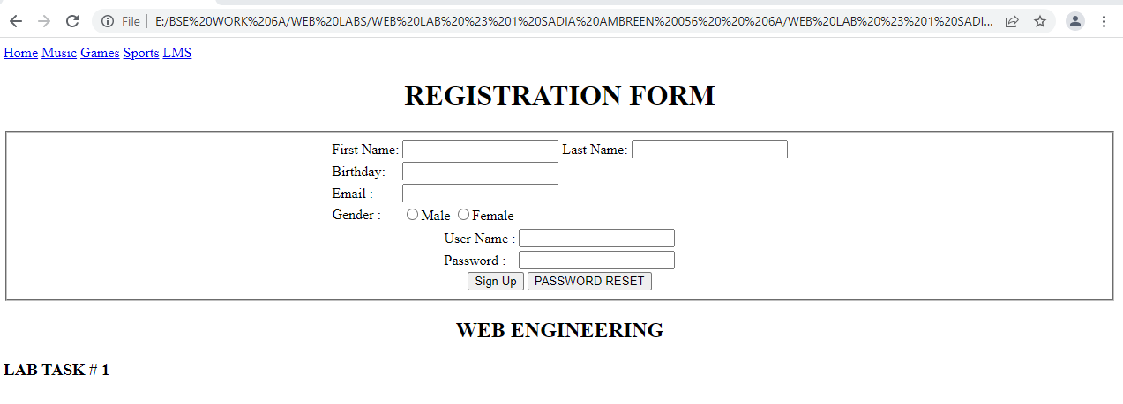

***Task # 2: code***

<!DOCTYPE html>

<html lang="en">

<head>

    <meta charset="UTF-100">

    <meta http-equiv="X-UA-Compatible" content="IE=edge">

    <meta name="viewport" content="width=device-width, initial-scale=5.0">

    <title>Document</title>

</head>

<body>

    <header>

        <nav> <a href="Home.html">Home</a>

            <a href="Music.html">Music</a>

            <a href="Games.html">Games</a>

            <a href="Sports.html">Sports</a>

            <a href="LMS OF BUKC.html">LMS</a>

        </nav>

    </header>

<h1>MUSIC</h1>

<h3>SELESCT YOUR FAVAROUITE MUSIC</h3>

<table>

    <tr>

        <BUTTON TYPE ="AGAR TUM SATH HO">AGAR TUM SATH HO</BUTTON><br/>

        <BUTTON TYPE ="KHAMOSHI">KHAMOSHI</BUTTON><br/>

        <BUTTON TYPE ="MAHI VE">MAHI VE</BUTTON><br/>

        <BUTTON TYPE ="RANJHA">RANJHA</BUTTON><br/>

        <BUTTON TYPE ="IK VAARI">IK VAARI</BUTTON><br/>

        <BUTTON TYPE ="LAE DOOBA">LAE DOOBA</BUTTON><br/>

    </tr>

    <tr> <td><BUTTON TYPE="ETC">ETC</BUTTON></td>

</tr>

        </table>

        <table>

            <h4>YOUR FAVORITE ARTISTS</43>

            <ul>  <li>Arjit Singh:</li>

                <img src="images/arjit.jpg" alt="Picture Of Arjit Singh "><br/>

                <li>Nusrat Fateh Ali Khan;</li>

                <img src="images/NFAK.jpg" alt="Picture Of Nusrat Fateh Ali Khan"><br/>

                <li>Atif Aslam;</li>

                <img src="images/Atif-Aslam-1.avif" alt="Picture Of Atif Aslam"><br/>

                <li>Diljit Dosanjh;</li>

                <img src="images/diljit.jpg" alt="Picture Of Atif Aslam"><br/>

                <li>Asim Azhar;</li>

                <img src="images/ASIM AZHAR.jpg" alt="Picture Of Asim Azhar "><br/>

            </ul>

</table>

<table>

    <tr>

        <td>SUBSCRIBE ARTISTS</td>

        <tr>

            <td><BUTTON TYPE ="Arjit Singh">Arjit Singh</BUTTON></td>

            <td><BUTTON TYPE ="Nusrat Fateh Ali Khan">Nusrat Fateh Ali Khan</BUTTON></td>

            <td><BUTTON TYPE ="Atif Aslam">Atif Aslam</BUTTON></td>

            <td><BUTTON TYPE ="Asim Azhar">Asim Azhar</BUTTON></td>

            </tr>

    </tr>

</table>

<footer>

    <center>

     <h2> WEB ENGINEERING </h2>

    </center>

    <h3>LAB TASK # 2 </h3>

 </footer>

</body>

</html>

***OUTPUT:***

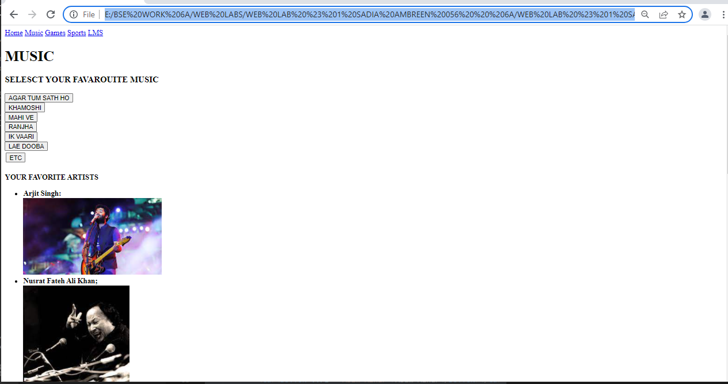

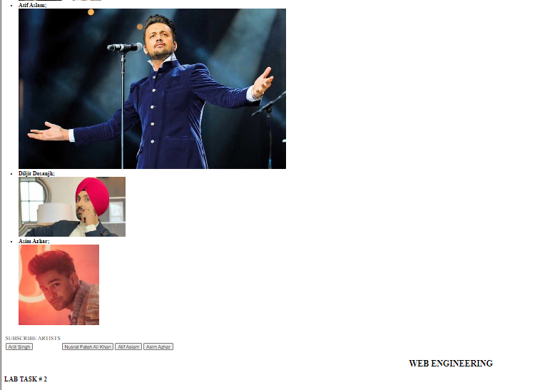

***Task # 3: code***

<!DOCTYPE html>

<html lang="en">

<head>

    <meta charset="UTF-8">

    <meta http-equiv="X-UA-Compatible" content="IE=edge">

    <meta name="viewport" content="width=device-width, initial-scale=1.0">

    <title>Document</title>

</head>

<body>

     <header>

         <nav>

                <a href="Home.html">Home</a>

                <a href="Music.html">Music</a>

                <a href="Games.html">Games</a>

                <a href="Criket Sport.html">Sports</a>

                <a href="LMS OF BUKC.html">LMS</a>

         </nav>

</header>

<center>

    <ul style="list-style-type:circle;"></ul>

<h3>IN-DOOR GAMES</h3>

<tr>

</tr>

    <li>Ludo  <td><button type="play" style="background-color:turquoise;">PLAY</button></td>  </li>

    </li>  Musical chairs  <li>Ludo  <td><button type="play" style="background-color:tomato;">PLAY</button></td>  </li>

 </li>

    <li> Picture puzzles <button type="play" style="background-color:Violet;">PLAY</button></td>  </li>

</li>

    <li> Carrom <button type="play" style="background-color:Gray;">PLAY</button></td>  </li>

</li>

    <li>   Scrabble <button type="play" style="background-color:turquoise;">PLAY</button></td>  </li>

 </li>

    <li>  Treasure hunt <button type="play" style="background-color:rgb(224, 64, 139);">PLAY</button></td>  </li>

</li>

</ul>

</center>

<h3>OUT-DOOR GAMES</h3>

<ol>

    <li>Criket</li>

    <li>football</li>

    <li>Badminton</li>

    <li>Basket ball</li>

    <li>Table tennis</li>

</ol>

</center>

<h3>DIFFERENT GAMES</h3>

<dl>

    <dt>CRIKET</dt>

    <dd>- Description Of CRIKET</dd>

    <dt>FOOTBALL</dt>

    <dd>- Description Of FOOTBALL</dd>

  </dl>

  <footer>

    <center>

     <h2> WEB ENGINEERING </h2>

    </center>

    <h3> WEB LAB TASK # 3 </h3>

 </footer>

</body>

</html>

***OUTPUT:***

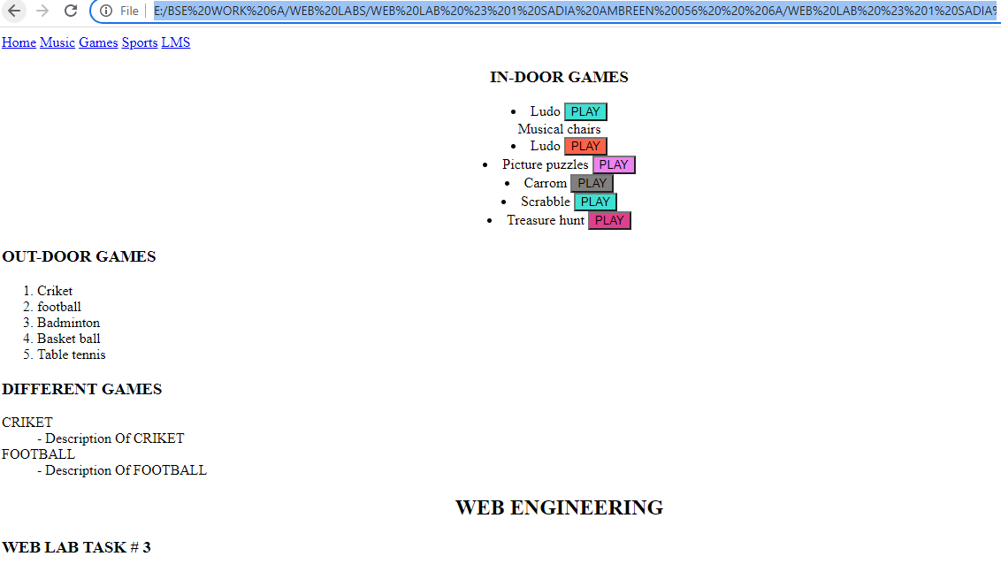

***Task # 4: code***

<!DOCTYPE html>

<html lang="en">

<head>

    <meta charset="UTF-8">

    <meta http-equiv="X-UA-Compatible" content="IE=edge">

    <meta name="viewport" content="width=device-width, initial-scale=1.0">

    <title>Document</title>

</head>

<body>

     <header>

         <nav>

                <a href="Home.html">Home</a>

                <a href="Music.html">Music</a>

                <a href="Games.html">Games</a>

                <a href="Criket Sport.html">Sports</a>

                <a href="Contact_Us.html">Contact Us</a>

                <fieldset>

                  <center>

              <form action="#" method="post">

         </nav>

        </center>

</header>

<center>

<h3>FAMOUS CRIKETERS</h3>

</center>

<ul style="list-style-type:square;"></ul>

<tr>

    <section>

  <nav>

    <ul>

      <li><a href="#">BABAR AZAM</a></li>

      <li><a href="#">SHAHID AFRIDI</a></li>

      <li><a href="#">SHAHDAB KHAN</a></li>

      <li><a href="#">SHAHEEN AFRIDI</a></li>

    </ul>

  </nav>

<div>

</tr>

    <h4>BABAR AZAM  <td><button type="LIKE" style="background-color:turquoise;">LIKE</button></td>

        <IMG src="images/BABAR.webp" style="width: 700px; height: 400px;"><br/>

        <p>Babar Azam, is a Pakistani international cricketer who captains Pakistan in all formats.

             He captains Karachi Kings in the PSL and captains Central Punjab in domestic cricket.

              In April 2021, he achieved the number one spot in the ICC rankings for ODI batsmen.

        </p></h4><br/>

    </section></h4>

  </h5>SHAHID AFRIDI<li><button type="LIKE" style="background-color:tomato;">LIKE</button></td>

      <img src="images/Shahid-Afridi.webp "style="width: 700px; height: 400px;"><br/>

        <P>Sahibzada Mohammad Shahid Khan Afridi, known as Shahid Afridi, is a former Pakistani cricketer and captain of the Pakistan national cricket team. Afridi is widely considered as one of the most destructive cricketers.

             An all-rounder, Afridi bowled leg spin and was recognized for his aggressive batting.

             </P><br/>

        </h5>

    <h6> SHADAB KHAN <button type="LIKE" style="background-color:Violet;">LIKE</button></td>

      <img src="images/Shadab-Khan.jpg" style="width: 700px; height: 400px;"><br/>

        <P>Shadab Khan is a Pakistani cricketer who plays for the Pakistan national cricket team. He was born in Mianwali, a city in northwest Punjab, Pakistan.

           In August 2018, he was one of thirty-three players to be awarded a central contract for the 2018–19 season by the Pakistan Cricket Board.</P>

        </h6>

    <h7> SHAHEEN AFRIDI <button type="LIKE" style="background-color:Gray;">LIKE</button></td>

      <img src="images/SAHEEN.jpg "style="width: 700px; height: 400px;"><br/>

      <P></P>  Shaheen Shah Afridi is a Pakistani professional cricketer who plays as a fast bowler for the Pakistan national cricket team. He made his international debut for Pakistan

        in April 2018 and his Test match debut for the national team in December 2018.

    </P>

  </h7>

</div>

</ul>

<h3>DESRIPTION</h3>

<dl>

    <dt>PSL CRIKET</dt>

    <dd>- Description Of PSL</dd>

    <dt>WORLD CUP 2022</dt>

    <dd>- Description Of WORLD CUP</dd>

  </dl>

  <footer>

    <center>

     <h2> WEB ENGINEERING </h2>

    </center>

    <h3> WEB LAB TASK # 4 </h3>

 </footer>

</body>

</html>

***OUTPUT:***

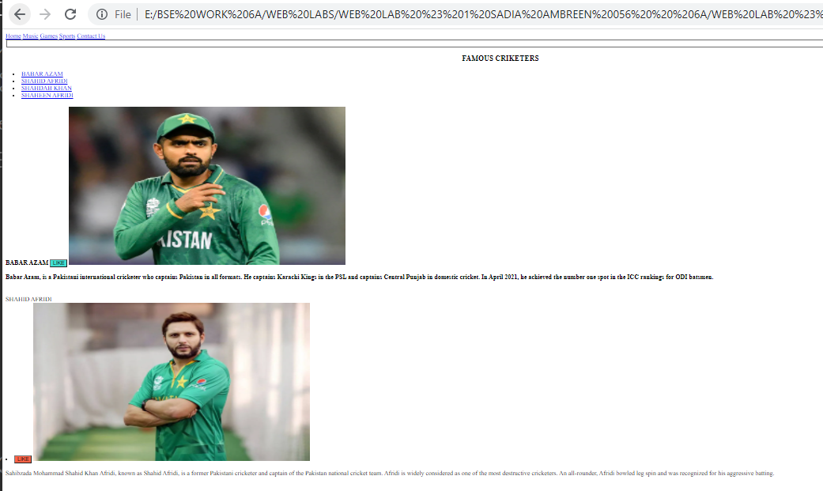 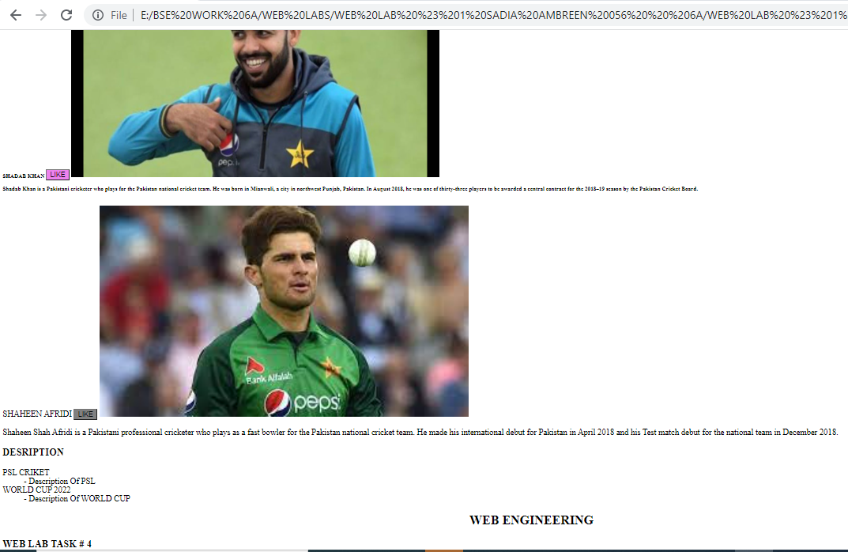

***Task # 5: code***

<!DOCTYPE html>

<html lang="en">

<head>

    <meta charset="UTF-8">

    <meta http-equiv="X-UA-Compatible" content="IE=edge">

    <meta name="viewport" content="width=device-width, initial-scale=1.0">

    <title>Document</title>

</head>

<body>

    <header>

        <a href="Home.html">Home</a>

        <a href="Music.html">Music</a>

        <a href="Games.html">Games</a>

        <a href="Criket Sport.html">Sports</a>

        <a href="LMS OF BUKC.html">LMS</a>

    </header>

<center><h1>STUDENT LOGIN</h1></center>

<center><h1>LEARNING MANAGEMENT SYSTEM</h1></center>

    <fieldset>

        <center>

    <form action="#"  method="post">

        <table style="width:100%;max-width:550px;border:0;" cellpadding="15" cellspacing="0">

        <tr>

            <td>

        <label for="ENROLLMENT">ENROLLMENT</label>

        </td>

        <td>

        <input name="ENROLLMENT " type="text"  />

        </td> </tr>

         <tr>

             <td>

        <label for="PASSWORD">PASSWORD</label>

        </td>

        <td>

        <input name="PASSWORD" type="text"  />

        </td>

        </tr>

        <tr>

            <td>

        <label for="FromEmailAddress">EMAIL ADDRESS</label>

        </td>

        <td>

        <input name="FromEmailAddress" type="text"  />

        </td>

        </tr>

        <tr>

            <td>

        <label for="ARE YOU ROBOT">ARE YOU ROBOT?</label>

            </td>

        <td>

       <input type="checkbox" name="checkbox" >

        </td>

        <td>

            <label for="KEEP ME LOGED IN?">KEEP ME LOGED IN?</label>

                </td>

            <td>

           <input type="checkbox" name="checkbox" >

            </td>

        </tr>

        <tr>

            <td ><button type="SUBMIT" style="background-color: rgb(226, 223, 43);">SUBMIT</button></td>

          </td>

        </tr>

        <tr>

          <td>

            <a href= "NEW STUDENT" >NEW STUDENT </a>

           <a href= "FORGET PASSWORD" >FORGET PASSWORD</a>

          </td>

        </tr>

        </table>

        </form>

    </center>

    </fieldset>

    <footer>

        <center>

         <h2> WEB ENGINEERING </h2>

        </center>

        <h3> WEB LAB TASK # 5 </h3>

     </footer>

</body>

</html>

***OUTPUT:***

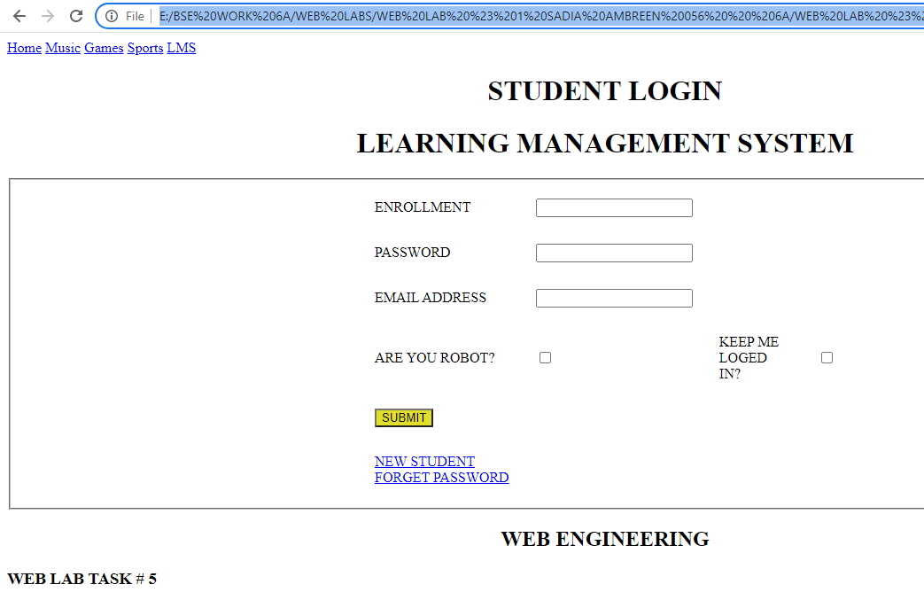

***GROUP LEADER Task # : code***

<!DOCTYPE html>

<html lang="en">

<head>

    <meta charset="UTF-20">

    <meta http-equiv="X-UA-Compatible" content="IE=edge">

    <meta name="viewport" content="width=device-width, initial-scale=5.0">

    <title>Document</title>

    <style>

   img {

  max-width: 100%;

  height: auto;

}

        input[type=text] {

          width: 200%;

          padding: 12px 20px;

          margin: 8px 0;

          box-sizing: border-box;

          border: none;

          border-bottom: 2px solid rgb(0, 0, 0);

        }

        </style>

</head>

<body>

    <div>

    <center>

    <img src="images/buliding.jpg" style="width: 1200px; height: 300px;">

    <tr>

   <h1>Registration Info</h1></center>

    <fieldset>

        <center>

    <form action="#" method="post">

    </tr>

<table>

    <tr>

        <table>

            <td>NAME</td>

            <tr>

                <td><input type="text" name="NAME"   ></td>

            </tr>

    </tr>

    <tr>

        <td>BIRTHDAY</td>

    <tr>

        <td><input type="date" name="BIRTHDAY"></td>

        <td>GENDER</td>

        <td><input type="radio" name="GENDER" value="Male">Male

            <input type="radio" name="GENDER" value="Female">Female

        </td>

        <tr>

        <td>CLASS</td>

        <tr>

            <td><input type="text" name="CLASS"></td>

        </tr>

        <td>REGISTRATION CODE</td>

        <tr>

            <td><input type="text" name="REGISTRATION CODE"   ></td>

        </tr>

    <tr>

        <td><button type="SUBMIT" style="background-color:MediumSeaGreen;">SUBMIT</button></td>

    </tr>

</table>

    </form>

</center>

</fieldset>

    <footer>

        <h2> WEB ENGINEERING BONUS TASK </h2>

        <h3>EXTRA LEADER TASK</h3>

    </footer>

</div>

</body>

</html>

***OUTPUT:***

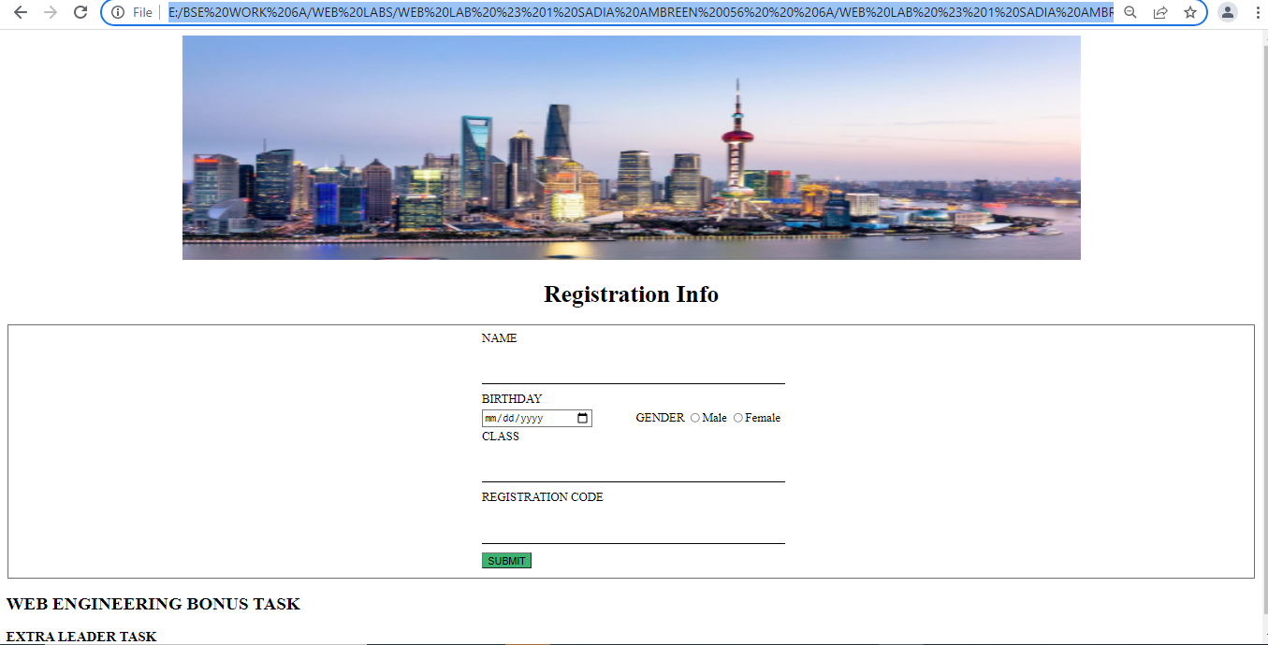

***\*\*\*\*\*\*\*\*\*\*\*\*\*\*\*\*\*\*\*\*\*\*\*\*\*\*\*\*\*\*\*\*\*\*\*\*\*\*\*\*\*\*\*\*\*\****

***THE END..***

***\*\*\*\*\*\*\*\*\*\*\*\*\*\*\*\*\*\*\*\*\*\*\*\*\*\*\*\*\*\*\*\*\*\*\*\*\*\*\*\*\*\*\*\*\*\****